HM Government of Gibraltar
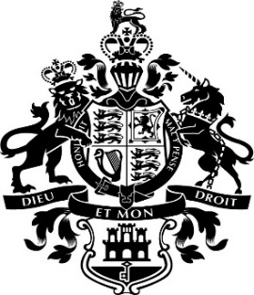

6 CONVENT PLACE

OFFICIAL NOTICE

Commonwealth Day – Monday 14th March 2016

All Government offices, including all Post Office counters, will be closed on Monday 14th March 2016.

There will be a collection of mail from all street pillar boxes at 7am followed by a mail delivery.

